First I will give user info, so it checks validity then checks ad_user_roles

let us say I took user as system - then user_id is 0

then go and check the roles in ad_user_roles

select * from ad_user_roles where ad_user_id=0;
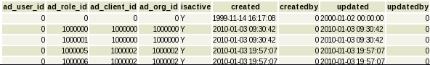

select * from ad_role where ad_role_id in ( select ad_role_id from ad_user_roles where ad_user_id=0);

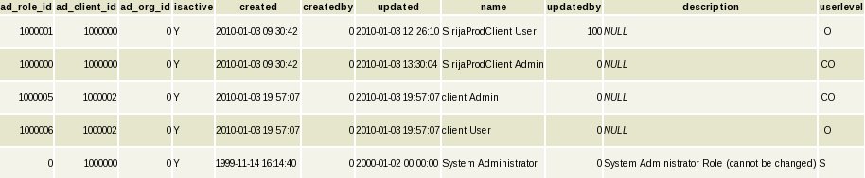

In GUI I selected system administartor, I mean role id is zero, so corresponding client is 100000. which is SirijaProdClient, so it shows the data.

select * from ad_role where ad_role_id in ( select ad_role_id from ad_user_roles where ad_user_id in ( select ad_user_id from ad_user where name ='SirijaProdOrg'));

